Day 4 - Verify Sync
Open Synchronization Service Manager
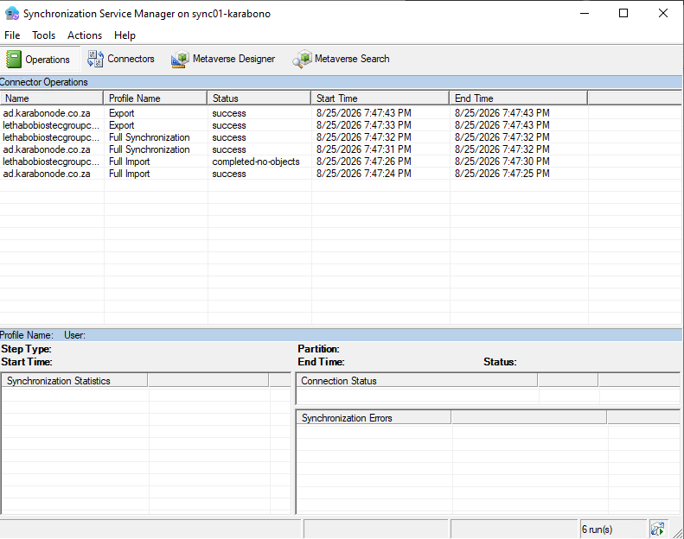
Check the sync cycle is scheduled
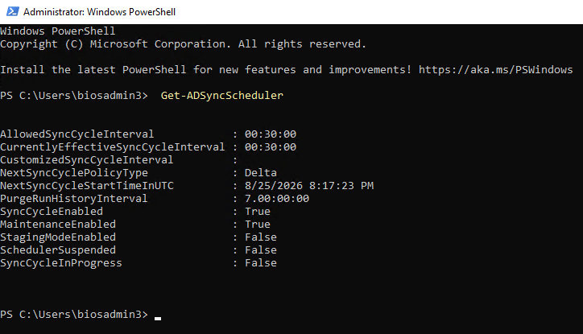
Confirm users landed in Entra
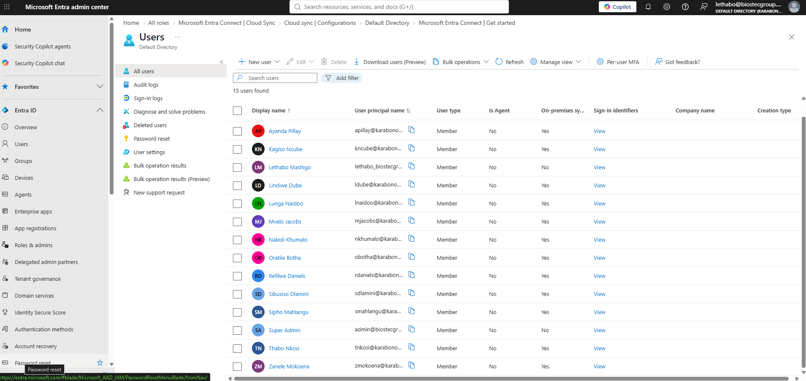
Why this matters
Confirms hybrid identity is actually working end to end, not just installed.
Skills covered
Synchronization Service Manager operations reading, the import/sync/export pipeline model, `Get-ADSyncScheduler`, distinguishing synced vs. cloud-native identities in Entra.

